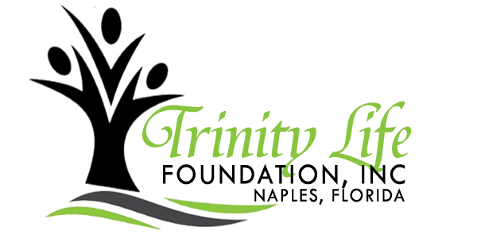
Making A Difference For
At-Risk Youth In Collier County
YOUTH PROGRAM ENROLLMENT FORM
Youth
First _______________________ Middle_______________ Last ____________________ Gender: Male__ Female__
School Name _______________________ Grade ______ Birth Date ___/___/_______ Age ________
Street Address _____________________________________________________________________________________
Town/City _______________________ State __________ Zip Code _________ Youth Home Phone _______________

Parent/Guardian- Contact Information
Parent/Guardian #1
First _____________________________ Last ______________________________ Ms. Mrs. Mr. Other _______
Street Address _____________________________________________________________________________________
Town/City _____________________ State _____ Zip Code _______ Home Phone ________ Daytime Phone_________
Cell Phone __________________ Fax ______________ Email_______________________________________________
Occupation ______________________________________ Employer _________________________________________
Child lives with: ____________________________________________________________________________________

Parent/Guardian #2
First _____________________________ Last ______________________________ Ms. Mrs. Mr. Other _______
Street Address _____________________________________________________________________________________
Town/City _____________________ State _____ Zip Code _______ Home Phone ________ Daytime Phone_________
Cell Phone __________________ Fax ______________ Email_______________________________________________
Occupation ______________________________________ Employer _________________________________________
Child lives with: ____________________________________________________________________________________

Emergency Contact Information- Alternate Pickup/Release
Emergency Contact #1
First Name ___________________________ Last Name ____________________________ Home Phone ____________
Cell Phone ____________________ Email _______________________________ Relation to Child _________________

Emergency Contact #2
First Name ___________________________ Last Name ____________________________ Home Phone ____________
Cell Phone ____________________ Email _______________________________ Relation to Child _________________

Please list those people, in addition to parents/guardians, who are permitted to pick up your child
1: ____________________________ 2: ______________________________ 3: _______________________________

Medical Release Information
Insurance Information
Policy Number ___________________________________ Name of Health Provider _____________________________
Primary Physician __________________________________________________________________________________
Address ___________________________________________________________________________________________
Phone ________________________________________ Hospital Preference ___________________________________

Please list any medical problems, including any requiring maintenance medication (i.e. Diabetic, Asthma, Seizures).
Medical Problem Required Treatment Should Paramedic be called?
____________________________ ________________________ Yes/No
____________________________ ________________________ Yes/No
____________________________ ________________________ Yes/No
Is your youth presently being treated for an injury, sickness, or taking any form of medication for any reason?
Yes _______ No _______ If yes, explain: ________________________________________________________________
Is your child allergic to any type of food or medication?
Yes _______ No _______ If yes, explain: ________________________________________________________________
Does your child require a special diet?
Yes _______ No _______ If yes, explain: ________________________________________________________________

The purpose of the above listed information is to ensure that medical personnel have details of any medical problem which may interfere with or alter treatment.
I understand that I will be notified in the case of a medical emergency involving my child. In the event that I cannot be reached, I authorize the calling of a doctor and the providing of necessary medical services in the event my child is injured or becomes ill.
Parent’s/Guardian’s Initials_____________________

I understand that the Trinity Life Foundation will not be responsible for the medical expenses incurred, but that such expenses will be my responsibility as parent/guardian
Parent’s/Guardian’s Initials_____________________

Please circle how you heard about the Trinity Life Foundation.
After School Program Website School Word of Mouth Flyer Other _____________

Terms of Agreement
Photo Release
I hereby give my permission for my child to be photographed during the workshop sessions. I understand the photos will be used to keep a journal of activities to share during power point presentation and/or reports to our donors and for promotional purposes including flyers, brochures, newspaper and on the internet. I understand that although my child’s photograph may be used for advertising, his or her identity will not be disclosed, I do not expect compensation and that all photos are the property of the Trinity Life Foundation.
Parent’s/Guardian’s Initials_____________________
Transportation Release
I hereby give permission for the transportation of my child for official Youth Sessions activities by modes of transportation agreed to by the TLF organizers.
Parent’s/Guardian’s Initials_____________________
The Trinity Life Foundation and its co-organizers are not responsible for lost or damaged personal property. All scheduled events are subject to change. Students’ photos and quotes may be used for publicity purposes. In case of an emergency, and if a family member cannot be reached, I hereby authorize my child to be treated by Certified Emergency Personnel (i.e. EMT, First Responder, and/or Physician).
I understand, acknowledge and agree that Trinity Life Foundation, will provide for reasonable supervision of students within its care and control. The supervision will be consistent with the ages of the students. However, the Trinity Life Foundation Board is not an insurer of the safety of the students nor can it supervise all movements of all students at all times. In addition, there are certain risks inherent in travel and at the destination. I further understand that an employee or volunteer has no personal liability unless he or she has acted recklessly, wantonly, or intentionally to injure my child.

Parent/Guardian Signature: _________________________________________________ Date ______________________
Printed Name of Parent/Guardian: ______________________________________________________________________

